Project: Text Redaction

In this project, we created a system which detects "sensitive" items in the text. Once identified, the system will redact these sensitive items such as names, dates, addresses (city, state and country). After redacting the sensitive items, the program will save redacted file as a new file with the .txt extension in the current folder. We are using SpaCy module from Natural Language Processing with python.

We created an EC2 instance and connected to the instance.

[ec2-user@ip-10-1-11-131 ~]$ python3 --version

Python 3.9.16

Here, we are installing pip.

[ec2-user@ip-10-1-11-131 ~]$ sudo yum install python3-pip

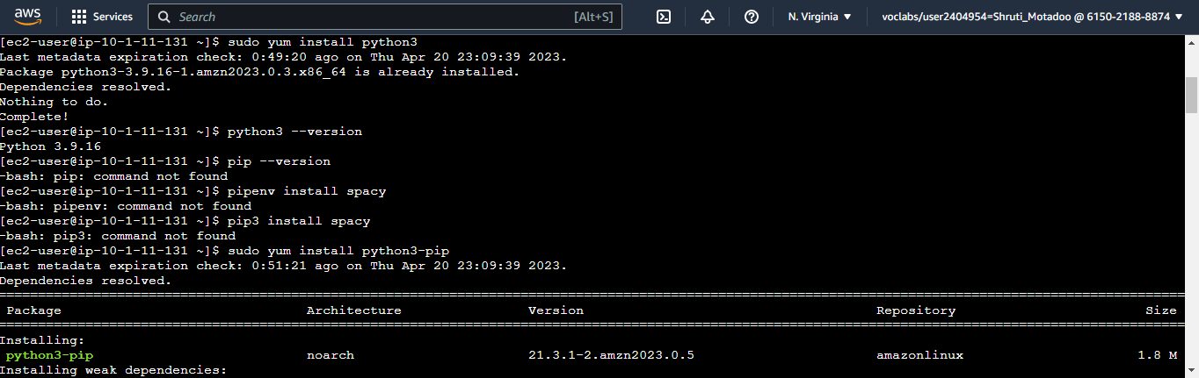

Then, we install spacy using the command pip3 install spacy.

Now, we download en_core_web_sm module using below command,

python3 -m spacy download en_core_web_sm

Created a text file using vim data.txt : Input data File



Created a python file using vim seppro.py : It redacts name, address(city, state and country) and date. It replaces name, address(city, state and country) and date with [REDACTED].



To execute we run the following command,

python3 seppro.py

Output file redacted_data.txt is created with redacted name, address and date.



